**Table contents**

1. **Abstract………………………………………………….. 2**
2. **System Requirement…………………………………….. 2**
3. **Specification…………………………………………..….. 3**
4. **Working………………………………………………….. 4**
5. **Introduction……………………………………. 5**
6. **Check Balance………………………………… 7**
7. **Withdraw Amount...………………………….. 8**
8. **Deposit Amount ………………………………. 10**
9. **Exit Program…………………………………... 12**
10. **Conclusion…………………………………………………. 13**

**Abstract:**

The ATM system is the project which is used to access the bank accounts in order to make cash withdrawals. Whenever the user need to make cash withdraws, they can enter their PIN and it will display the amount to be withdrawn. Once their withdrawn was successful, the amount will be debited in their account. This mini project contains fewer features but the essential ones.

Features of ATM system, first the user has to enter correct PIN to access ATM account. Then the system displays some options one is Check balance, second is Withdraw Amount, third is Deposit Amount and the fourth one is Exit Program. ATM enables the clients of a bank to have access to their account without going to the bank.

The ATM will service one customer at a time. A customer will be required to enter ATM card, PIN both of which will be sent to the database for validation as part of each transaction. The customer will then be able to perform one or more transactions. Also customer must be able to make a balance inquiry of any account linked to the card.

The ATM will communicate each transaction to the database and obtain verification that it was allowed by the database. In the case of a cash withdrawal, a second message will be sent after the transaction has been physically completed. If the database determines that the customer’s PIN is invalid, the customer will be required to re-enter the PIN before a transaction can proceed.

If a transaction fails for any reason other than an invalid PIN, the ATM will display an explanation of the problem and will then ask the customer whether he/she wants to do another transaction.

The ATM will provide the customer with a printed receipt for each successful transaction, showing the date, time, type of transaction, account amount, and ending and available balance of the affected account.

ATM system is developed using C++ Programming Language and different variables, if-else-if statement, strings also used for the development of it.

The automated teller machine was invented by john Shepherd-Barron in the year of 1960.

**System Requirements:**

This system “Automated Teller Machine” consist of very cheap and low requirements that are reasonable and affordable.

* A low end PC minimum requirements for the computer are given below:

1. At least 1 GB of ram DDR 2 or above
2. 500 MB of free space
3. Keyboard
4. Windows XP / Vista / 7 / 8.1 / 10
5. DEV C++

**Specifications:**

* **Low Size :**

Its size is very low, it's about 30 to 40 KB but it will give us unrespectable result.

* **Fast :**

As we know it is in a very low size, and because of its low size it will give us faster processing speed and fastest result. That is the requirement of any system. And only these sort of systems are best in the market that give us speedy results.

* **Easy to use :**

The main and one of the best feature of this system is that it is easy to use. It does not require any sort of highly educated person to operate and use it, It’s quite user friendly.

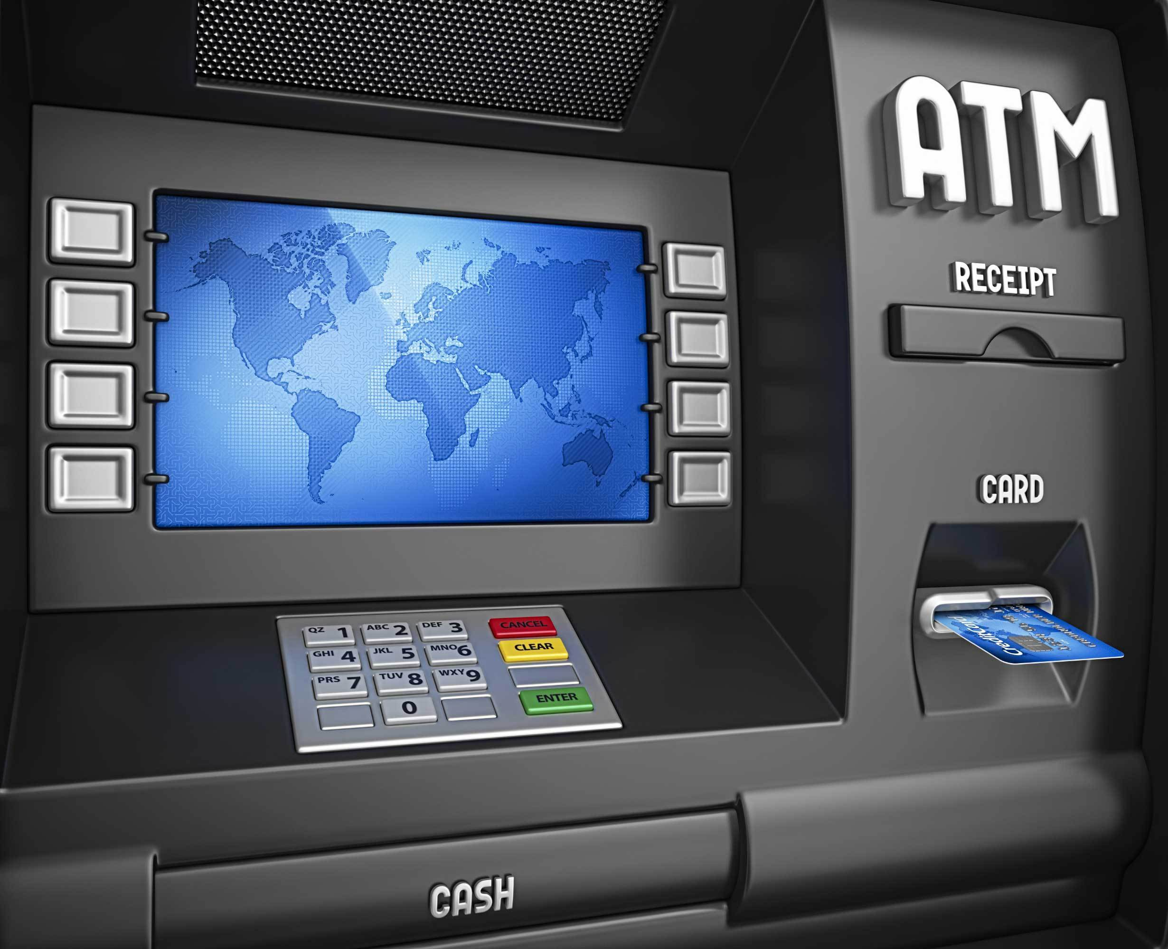

**Working:**

The automated teller machine (ATM) is an automatic banking machine that allows the customer to complete basic transactions without any help from bank representatives.  There are two types of automated teller machines (ATMs). The basic one allows the customer to only draw cash and receive a report of the account balance. Another one is a more complex machine that accepts the deposit, provides credit card payment facilities and reports account information.

It is an electronic device that is used by only bank customers to process account transactions. The users access their accounts through a special type of plastic card that is encoded with user information on a magnetic strip. The strip contains an identification code that is transmitted to the bank’s central computer by modem. The users insert the card into ATMs to access the account and process their account transactions.

In this program we use “Escape sequences” to display the output in the middle of screen, e.g., \n and \t.

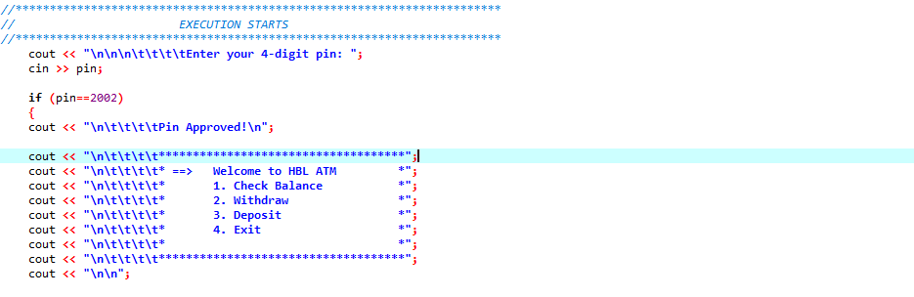

Figure (1.1)

In this block of code shown in Figure (1.1) , System has four main options, “Check Balance, Withdraw amount, Deposit amount and fourth option is Exit program”. All options are labeled with a serial number respectively. It will take a number that will be a serial number (1,2,3 and 4) which is labeled with the particular option shown in Figure (1.2).

**1.** Check Balance

**2**. Withdraw Amount

**3.** Deposit Amount

**4.** Exit Program

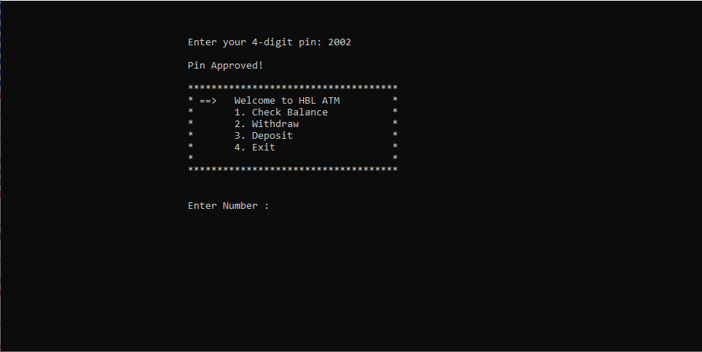

Figure (1.2)

**Introduction:**

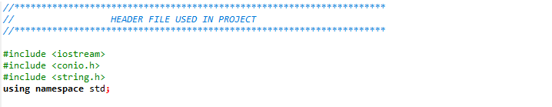

Figure (1.3)

These are the Header files used in the project.

#include <iostream> is used for input and output values which we use in the program.

#include <conio.h> is used for console input and output values.

#include <string.h> is used to display strings which we use in program.

Using namespace std is used to read “cin” and “cout” statements.

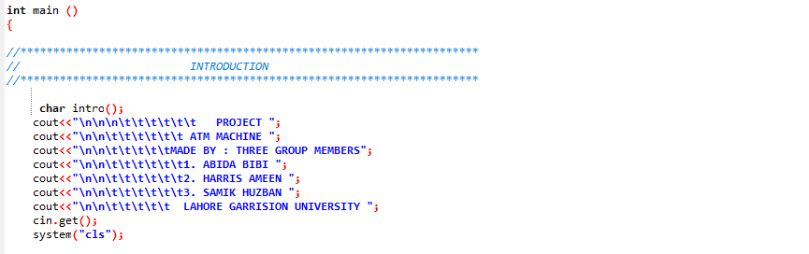

Figure (1.4)

Here is the introduction of group members. A code ‘system(“cls”) is used to clear the screen after displaying.

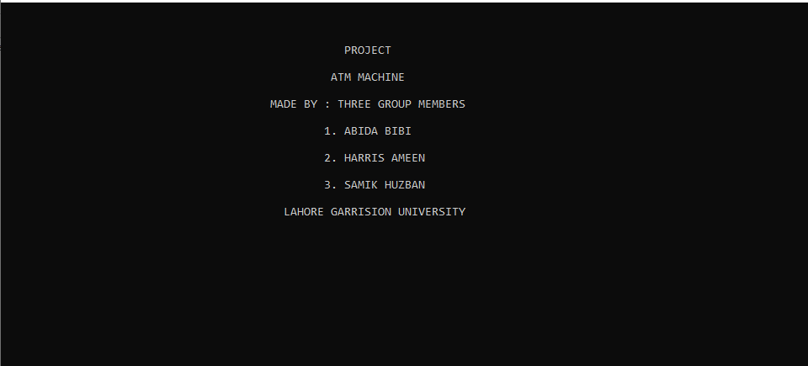

Figure (1.5)

Output of introduction of group members that is stored in the program. When we press enter after this displaying of introduction screen gets cleared and next screen will appear.

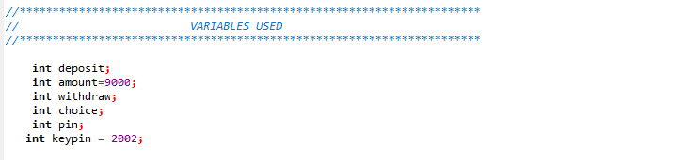

Figure (1.6)

In this figure variables that are used in program are declared. Here “int” datatype is used.

**Choices:**

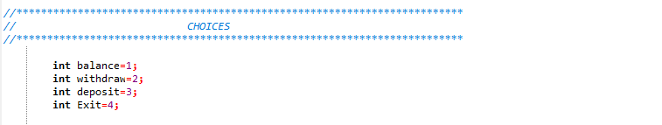

Figure (1.7)

Here are the choices for the user wanted to

**1.** Check Balance

**2.** Withdraw Amount

**3**. Deposit Amount

**4.** Exit Program

**Check Balance:**

It is the first option that will activate if user enters “1”. When the user enter 1 it will show the current balance in the user account. Here “if-else-if statement” is used. Its code and output is shown in figures below:

Code:

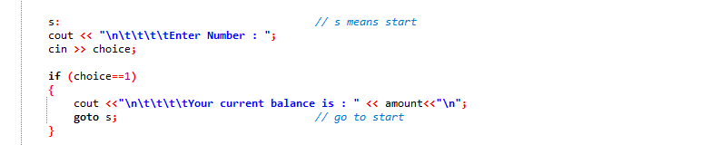

Figure (2.1)

Output :

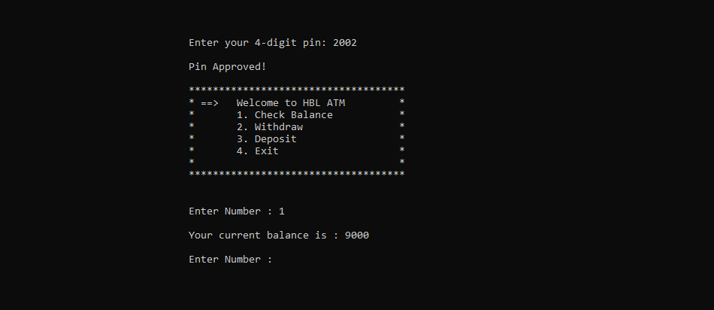

Figure (2.2)

**Withdraw Amount:**

This is second option which consists of withdraw amount. It is activated when user enters “2” from the keyboard. We use “if-else-if” statement and here are two options if the user withdraw amount greater than the current balance in the account than message will display that “you don’t have sufficient balance” see in figure (3.2) and the other option is if you with draw amount according to current balance in the account than after withdrawing user will see the remaining balance. See in figure (3.3). Its code is shown below:

Code:

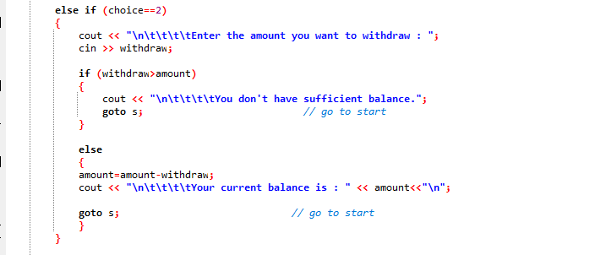

Figure (3.1)

Output of the program:

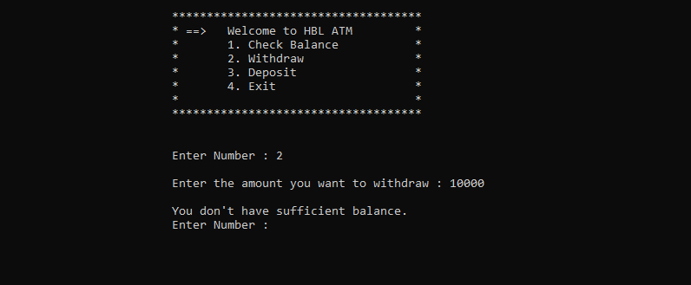

Figure (3.2)

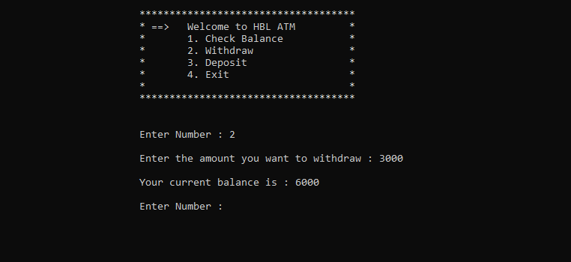

Figure (3.3)

**Deposit Amount:**

This is third option which consists of deposit amount. It is activated when user enters “3” from the keyboard. We use “if-else-if” statement and here user deposit amount in the account which he want to and amount will add up to the balance in the user account. After adding amount new balance is shown to the user. Its code is shown below:

Code:

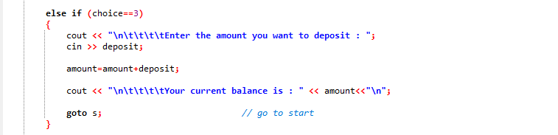

Figure (4.1)

Output of the program:

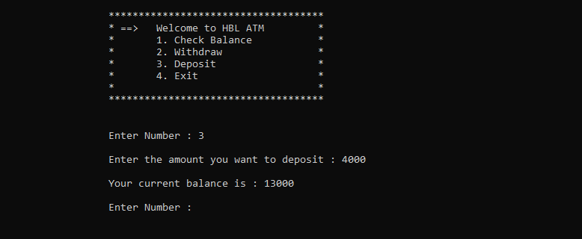

Figure (4.2)

After entering 3 user can also enter again option “1” and option “2”. For this we use “goto s” means again entering number from the choices. See figure (4.3) given below:

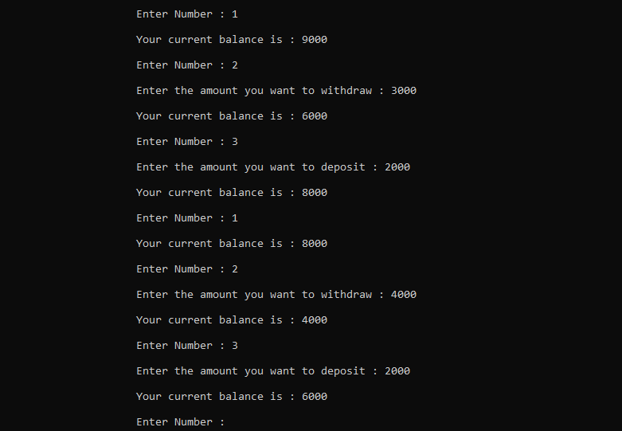

Figure (4.3)

**Exit Program:**

This is forth and last option ,that will stops the program execution. When user select this option and enters ‘4’ then the program exit. Its code is shown below:

Code:

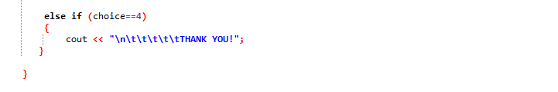

Figure (5.1)

Output of the program:

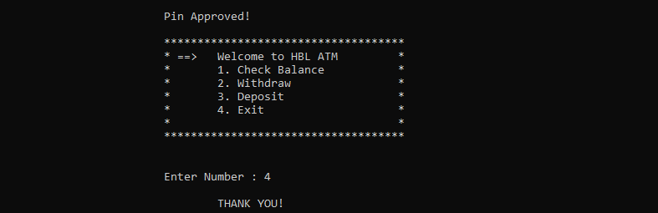

Figure (5.2)

**Invalid PIN :**

This Program will execute only if the user enter correct PIN. If user enter an invalid PIN then a message on the screen will display that “Invalid PIN” and “Please try again”.

Its code is shown below:

Code:

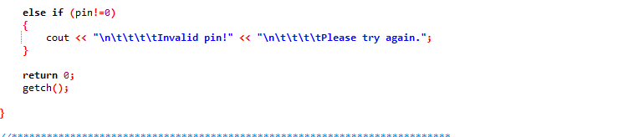

Output of the program:

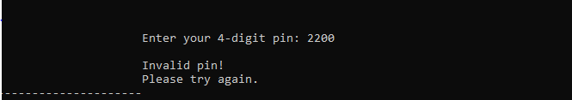

**Conclusion:**

This mini project contains fewer features but the essential ones. The system is designed to provide the user with the facility of remote banking and perform various other functions at an interface without any aid of human bank teller. It is a fast way to get money out of your account, especially when on the go or during a trip. We do plan to improve it further on user feedback, so suggestions and feedback will not only be welcomed but appreciated.